## **Week 4 Homework Submission File: Linux Systems Administration**

### **Step 1: Ensure/Double Check Permissions on Sensitive Files**

1. Permissions on /etc/shadow should allow only root read and write access.  
   * Command to inspect permissions:
     1. ls -l /etc/shadow
   * Command to set permissions (if needed):
     1. sudo chmod 600 /etc/shadow
2. Permissions on /etc/gshadow should allow only root read and write access.  
   * Command to inspect permissions:
     1. ls -l /etc/gshadow
   * Command to set permissions (if needed):
     1. sudo chmod 600 /etc/gshadow
3. Permissions on /etc/group should allow root read and write access, and allow everyone else read access only.  
   * Command to inspect permissions:
     1. ls -l /etc/group
   * Command to set permissions (if needed):
     1. sudo chmod 644 /etc/group
4. Permissions on /etc/passwd should allow root read and write access, and allow everyone else read access only.  
   * Command to inspect permissions:
     1. ls -l /etc/passwd
   * Command to set permissions (if needed):
     1. sudo chmod 644 /etc/passwd

### 

### **Step 2: Create User Accounts**

1. Add user accounts for sam, joe, amy, sara, and admin.  
   * Command to add each user account (include all five users):
     1. sudo adduser sam
     2. sudo adduser joe
     3. sudo adduser amy
     4. sudo adduser sara
     5. sudo adduser admin
2. Ensure that only the admin has general sudo access.  
   * Command to add admin to the sudo group:
     1. sudo usermod -G sudo admin

### **Step 3: Create User Group and Collaborative Folder**

1. Add an engineers group to the system.  
   * Command to add group:
     1. sudo addgroup engineers
2. Add users sam, joe, amy, and sara to the managed group.  
   * Command to add users to engineers group (include all four users):
     1. sudo usermod -G engineers sam
     2. sudo usermod -G engineers joe
     3. sudo usermod -G engineers amy
     4. sudo usermod -G engineers sara
3. Create a shared folder for this group at /home/engineers.  
   * Command to create the shared folder:
     1. sudo mkdir /home/engineers
4. Change ownership on the new engineers' shared folder to the engineers group.  
   * Command to change ownership of engineer's shared folder to engineer group:
     1. sudo chmod 474 engineers/
     2. sudo chown :engineers /home/engineers/

### **Step 4: Lynis Auditing**

1. Command to install Lynis:
   * sudo apt-get install lynis
   * sudo apt install lynis
2. Command to see documentation and instructions:
   * man lynis
   * sudo lynis -h
3. Command to run an audit:
   * sudo lynis audit system
   * sudo lynis audit system | grep
4. Provide a report from the Lynis output on what can be done to harden the system.  
   * Screenshot of report output:

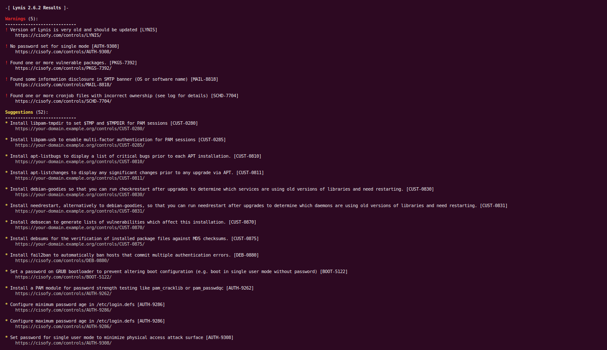

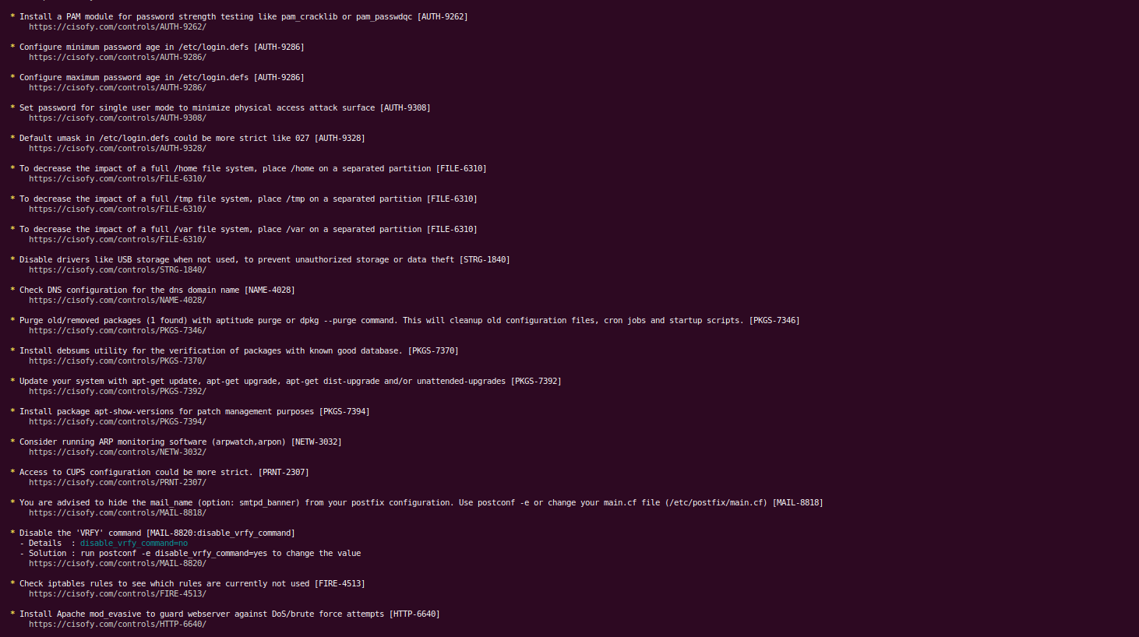

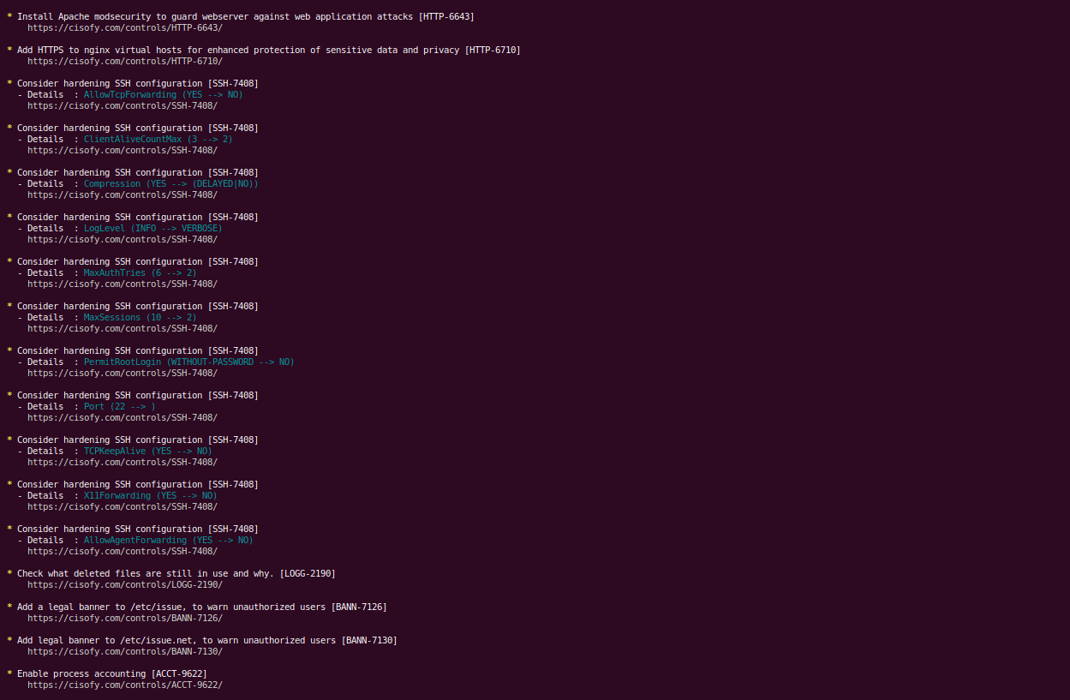

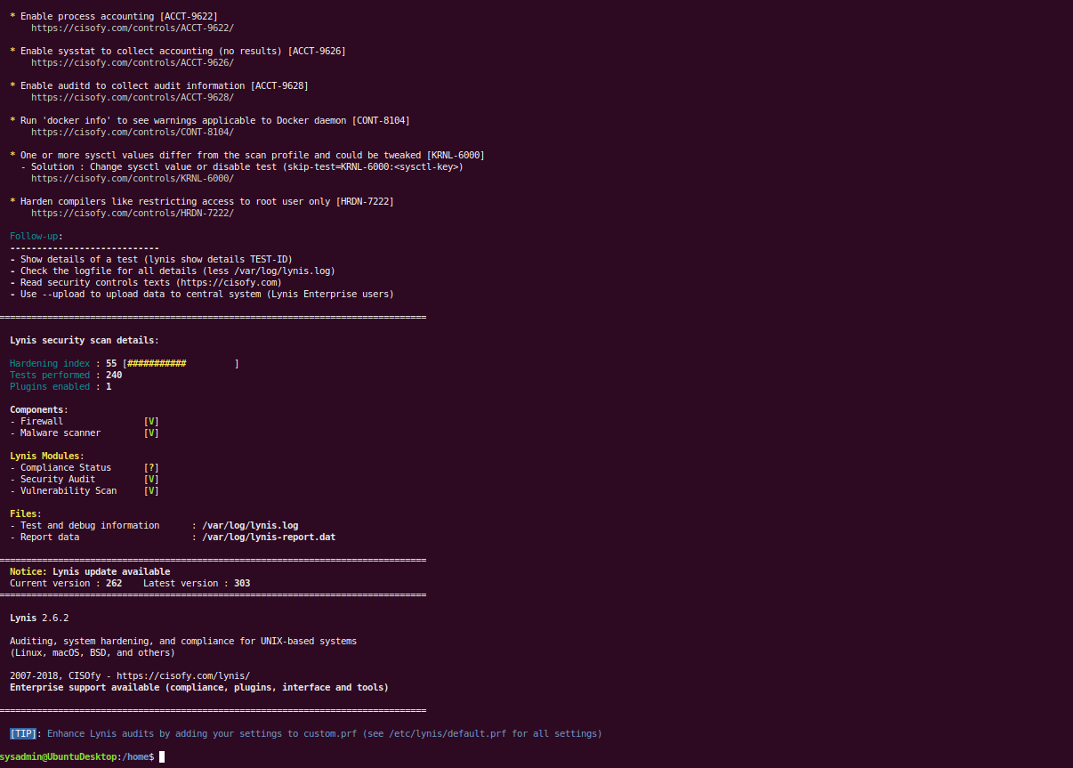

### **Bonus**

1. Command to install chkrootkit:
   * sudo apt-get install chkrootkit
   * sudo apt install chkrootkit
2. Command to see documentation and instructions:
   * man chkrootkit
   * sudo chkrootkit -h
3. Command to run expert mode:
   * sudo chkrootkit -x
4. Provide a report from the chrootkit output on what can be done to harden the system.  
   * Screenshot of end of sample output:

